**SafeJourn - Progress Report**

**Course: Final Year Project**

**Code: CS 491**

**BS (CS) Fall 2020**



**Supervisor:** Dr. Zulfiqar Ali Memon

**Co-Supervisor:** Mr. Sayed Yousuf

**Team Members:**

Muhammad Shaheryar Khalid – K173907

Fizza Jawed – K173826

Arbaz Sohail – K173845

**Abstract:**

We live in a country where risk and instability are much more than that of any other nation. Considering the risks, Children are the most vulnerable of all. They should be fully protected so that they can survive, grow, learn and develop to their fullest potential. To support the cause, A secured van registration and tracking system will be designed and formulated where each movement will be under observation to the affiliates of the traveler. The idea is to facilitate the van drivers by offering them the shortest and the fastest routes using the real-time traffic considering each pick-up point of the registrant and providing the real-time location of the pickup van to the registered mobile. The tracking will be done using the GPS in the mobile phones of the drivers which will enable the consumer to know the location of their child.

1. **Introduction:**

As we all know that the children are an important asset of a nation. If the growth of youth is harmed or restricted through any means, the countries take full responsibility and bring in innovative ideas to cater the problems and restrictions faced by the youth.

Pakistan is experiencing numerous threats. Considering them all, the reality of child abductions is serious and risks involved in it are common. The abduction of a child by anyone is one of the most devastating crisis that a parent could ever encounter.

The impact on the abducted child is also traumatic. Countries are taking strict actions against it and are developing ideas to tackle such problems. Parents these days are more towards the security of their children and the only way through which one can rely on is safety precautions.

To support the cause, the idea to work for the SafeJourn and develop something for the safety of students was required.

1. **Gap Analysis:**

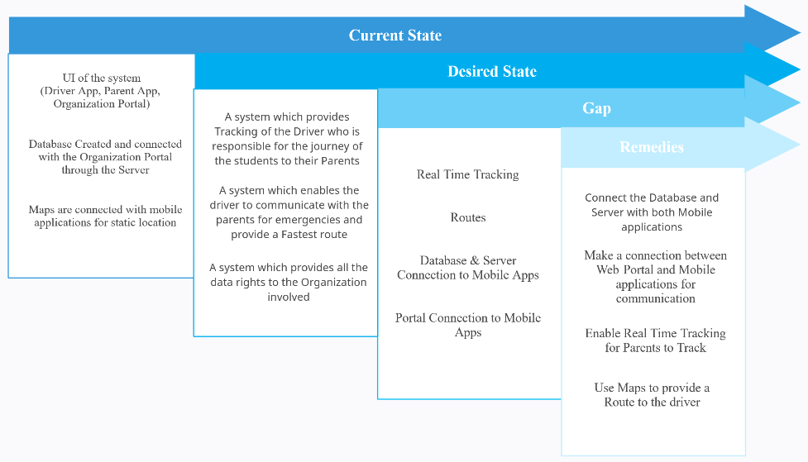Figure 1: Gap Analysis of SafeJourn.

1. **Requirements Analysis:**
   1. **Non-Functional Requirements:**
      1. Performance Requirements

For SafeJourn to work properly, Parents are Drivers are required to have a smartphone and an active internet connection with them whereas an organization is required to have a desktop PC and an active internet connection to fully use the website.

* + 1. Safety Requirements

SafeJourn does not work with inactive internet connections. A possible loss of route or tracking or login can be expected in case users have an inactive internet connection. To avoid the situations users are preferred to stay close to strong internet connections. In case a student has a dry hand, it might create a hassle for attendance.

* + 1. Security Requirements

Users will be registered on the system with personal information. This information will be closed to end users. The hashing method will also be used when user passwords are stored. In addition, the fingerprints will also be stored in the database using hashing technique. Thus, there will be no problem with the security and sharing of the information of the users who are using app or web application.

* 1. **Functional Requirements:**
* **Tracking**

SafeJourn should be able to provide a detailed tracking of the student.

* **Registration**

The System should be able to register users to the organization.

* **Notifications**

The system should be able to provide relevant updates to the users via Notification panel.

* **Admin Rights**

The system should be able to provide an organization every right to access the data.

1. **Features:**
   1. **Tracking**

Tracking of entire journey will be done. Parents, administration and driver will have access to the real time Map.

**4.2 Registration**

Students and Drivers can register themselves to the organization but will only bevalidated if an organization approves the registration.

**4.3 Notifications**

Entire real time tracking and updates of journey will be notified.

**4.4 Admin Rights**

Admin will have rights to give controlled access to Parents/Drivers.

1. **Design Details:**

Figure 2: State diagram of Driver’s and Parent’s Application.

Figure 3: State diagram of Organization and Student.

Figure 4: Detailed explanation using Class Diagram.

1. **Implementation Details:**

Following are the tools which are used to build the SafeJourn’s Front-end and Database.

* Visual Code
* PHPMyAdmin and Xampp
* GitHub
* GCP (Google Cloud Platform APIs)

1. **Testing:**

Testing of the Google Map API was performed by searching locations through scrolling google map. Rest of the testing is performed for login and registering users to the organization.

1. **Outputs of the product:**

**Web Portal:**

Following are the Screenshots of the SafeJourn’s web portal for the organization.

Snippet 1. Login Page

Snippet 2. Home Page

Snippet 3. Registered Students

Snippet 4. Tracking details of vans.

Snippet 5. Attendance record of drivers.

Snippet 6. Record of Students attendance.

Snippet 7. Portal to register students.

Snippet 8. Portal to register parents for the registered students.

Snippet 9. Portal to register van drivers to the organization.

**Parent Application:**

**Driver Application:**

1. **Code:**

|  |
| --- |
| **Google Map API** |
|  |

|  |
| --- |
| **Parent Application** |
|  |
| **Driver Application** |
|  |

|  |
| --- |
| **Organization Portal** |
| import React, { Component, useState } from "react";  import { axios } from "axios";  import "./App.css";  import {Switch,Route,BrowserRouter as Router} from 'react-router-dom';  import Signin from '../src/pages/signin';  import Mainpage from '../src/pages/mainpage';  import SignupParent from '../src/pages/signup';  import SignupStudent from '../src/pages/singup2'  import Maps from '../src/pages/Maps';  import Driver from '../src/pages/Driver';  import DriverDetail from '../src/pages/DriverDetails'  import StudentAttendace from '../src/pages/StudentAttendance'  // import Tracking from '../src/pages/tracking';  // import Vanscreen from '../src/pages/vanscreen';  import Profilepage from '../src/pages/Profilepage';  import PushNotification from '../src/pages/PushNotification'  function App() {  return (  <Router>  <Switch>  <Route path="/" exact={true} component={Signin} />  <Route path="/Attendance" component={Maps} />  <Route path="/Profilepage" component={Profilepage} />  <Route path="/Student" component={Mainpage} />  <Route path="/Register" exact={true} component={SignupParent} />  <Route path="/reg" exact={true} component={SignupStudent} />  <Route path="/Driver" component={Driver} />  <Route path="/DriverDetail" exact={true} component={DriverDetail} />  <Route path="/StudentAttendance" exact={true} component={StudentAttendace} />  <Route path="/PushNotification" component={PushNotification} />  <Route component={Signin} />  </Switch>  </Router>  );  }  export default App; |

1. **Limitations of the system:**

Authorized users (Parents, Drivers) and organizations will have the access to the applications and web portal. The application and web portals are available in English language.

1. **Future work:**

The following functionalities can be implemented in the future:

* Student’s Tracking: An individual band/watch for the tracking of student.
* Attendance via Face detection.

1. **Conclusion:**

The project is on time. FYP-1 requirements that are front-end and database have been built. For the FYP-2 entire backend along with the tracking and attendance monitoring using thumb impression will be performed.